The 23rd World Forum on Advanced Materials (POLYCHAR) (derived from Polymer Characterization) returned to the United States for the first time since 2003, when this conference began changing venues annually. Previously, it had been hosted by the University of North Texas for the 11 years from its founding in 1992 by Witold Brostow, Michael Hess, and Kevin P. Menard. In the year 2015 POLYCHAR was hosted by the University of Nebraska, Lincoln (UNL), USA, and organized by a local organization committee (the Department of Mechanical & Materials Engineering and the College of Engineering) and an international organization committee with members from Belgium, France, South Korea, and Nepal, chaired by Prof. Mehrdad Negahban (UNL). The conference was supported by IUPAC, the IUPAC Polymer Division Samsung Fund, the US National Science Foundation, the University of Lincoln (UNL), the Office for Research and Educational Development (UNL), the College of Engineering (UNL), the Department of Mechanical & Materials Engineering (UNL), the City of Lincoln Convention and Visitors Bureau, and the John A. Woollam Company.
As said, early conferences have been held in Denton, Texas; then in Guimaraes, Portugal (2004); Singapore (2005); Nara, Japan (2006); Buzios, Brazil (2007); Lucknow, India (2008); Rouen, France (2009); Siegen, Germany (2010); Kathmandu, Nepal (2011); Dubrovnik, Croatia (2012); Gwangju, South Korea (2013); and Stellenbosch, South Africa (2014).
In 2015, there were 13 Sessions:
Characterization Methods and Structure-Properties Relations (15 contributions) Keynote: Jean-Michel Guenet (France), Characterization and Properties of Hybrid Materials from Polymers and Self-Assembled Systems
Predictive Methods, Modelling and Simulation (11 contributions) Keynote: Jean-Marc Saiter (France), Physical Aging and Cooperative Relaxation in Glassy Polymers
Biomaterials, Drug Delivery and Tissue Engineering Materials - Green Polymers, Green Engineering and Recycling (11) Keynote: Valerio Causin (Italy), Nanocellulose-Reinforced Gels for Biomedical Applications; Victor Castaño (Mexico), Advanced Natural Materials: From Rice Husk to Aerospace Systems
Fibers, Interfaces and Composites (6)

Nanomaterials and Smart Materials (10) Keynote: Yuri Dzenis (USA), Simultaneous Strong and Tough Continuous Polymer Nanofibres and Nanocomposites
Dielectric-, Electrical-, Magnetic-, Optical- and Optoelectronic Properties (8)
Polymers in Electronics and Optoelectronic Devices (5)
Progress in Polymer Synthesis (5) Keynotes: Daniel Grande (France), Design, Synthesis, and Characterization of Functional Doubly Porous Crosslinked Polymers; Betty López (Colombia), A New Method to Modify Poly(arylene ethers) with a Mild Sulfonating Agent
Characterization with Scanning Probe Microscopy (4) Keynote: Dalia Yablon (USA), Advances in Atomic Force Microscopy Based Methods to Characterize Polymer Materials on the Nanoscale
Rheology, Solutions and Mechanical Properties and Performance (5)
Processing and and Properties of Semicrystalline Polymers (6) Keynote: Jean-Marc Lefebvre (France), In-Situ SAXS/WAXS Investigation on Deformation Induced Structural Evolutions in Amorphous and Semi-Crystalline Polymers; Andrzej Galeski (Poland), Crystallization and Melting Phenomena in Nanofibers Reinforced Polymer Nanocomposites
As always at this Forum, originality of research presented was an important goal, not maximum number of participants. The sessions included 87 oral contributions and 45 Posters, with 103 registered participants (including 42 students) from 21 countries and 5 continents. In addition to the US, there were participants from France, Belgium, Nepal, Singapore, Poland, South Korea, Germany, Japan, P.R. China, Republic of China, Malaysia, Austria, Portugal, Canada, India, Georgia, Colombia, Mexico and Ireland.
As always, it is difficult to provide the flavor of a conference. The following presentations are listed to give a somewhat better idea about the subjects:
Gila Stein (Young Scientsts’ Plenary), University of Houston, USA: Grazing Incidence Small-Angle X-Ray Scattering: Principles, Models, and Application for Nanostructured Thin Films
Abby Whittington (Young Scientsts’ Plenary), Virginia Tech: Polymer Characterization of Medical Devices for Use in Cancer Patients
Harald Ade, North Carolina State University, Raleigh: Soft X-Ray Characterization Methods: Utility and Opportunity
Stephen Cheng, University of Akron: Giant Polyhedra and Giant Surfactants Based on Nano-Atoms: Tuning from Crystals, to Quasicrystals, to Frank-Casper Phases: An Interconnection Between Soft and Hard Matter
Richard Laine, University of Michigan, USA: Synthesis, Processing and Properties of Silesquioxane Macromonomers and Polymers
Rachel Seligman, University of California, Santa Barbara: Using Bioinspired Polymers to Explore the Role of Sequence on Controlling Polymer Properties
There was an talk on Recent Developments in the IUPAC Polymer Division by Michael Hess. The full program can be found at: http://polychar23.unl.edu/downloads/Sessions_Program.pdf
The Forum was preceded by a Course on Polymer Characterization – a remnant of the earlier narrower focus of these conferences, but useful for understanding of research presentations later (each including a 50 minutes lecture + discussion):
Dynamic-Mechanical Analysis (Michael Hess, University of North Texas)
Rheology & Processing (Dirk Schubert, University of Erlangen-Nuremberg, Germany)
Characterization of Polymeric Nanostructures with Combined Scanning Probe and Fluorescent Microscopy (Holger Schoenherr, University of Siegen)
Glass transitions and glass transition temperatures (Jean-Marc Saiter, Université de Rouen)
Micromechanics of Polymers: Micro- and Nanoscopic Processes of Deformation and Fracture (Sven Henning, Fraunhofer Institute for Mechanics of Materials, Halle)

Solid State NMR (Bernhard Bluemich, Technical University of Aachen (RWTH))
Basics of Scattering Techniques: X-Ray, Neutron, Light (Jean-Michel Guenet, Charles Sadron Institute and University of Strasbourg)
Photochemistry in Polymer Science (Brett Fors, Cornell University, Ithaca, New York)
Friction, Wear and Scratch Resistance of Polymers (Nathalie Hnatchuk, University of North Texas)
The Conference was opened by the Conference Chair, Mehrdad Negahban (UNL), followed by welcome addresses by the Vice-Chancellor for Research & Economic Develoment at UNL, Prem Paul; the Chair of the Department of Mechanics & Materials Engineering, Jeff Shield; the Dean of the College of Engineering, Tim Wei; and Michael Hess, IUPAC Polymer Division (University of North Texas).
The prestigious Paul J. Flory Research Prize 2015 went to Kohji Tashiro (below in the middle), Toyota Technological Institute, Nagoya, for his Clarification of Microscopically-Viewed Structure-Property Relationships of Polymeric Materials.
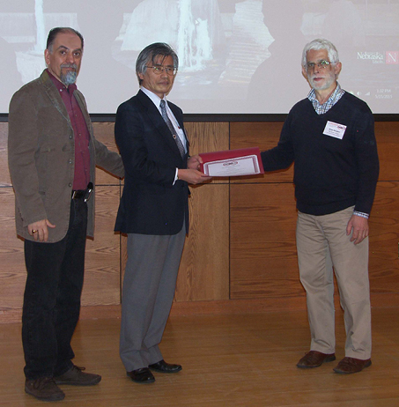
The International Materials Research Prize was given (ex aequo) to Valerio Causin, University of Padua, Italy, for his contribution to the structural and morphological characterization of materials by small-angle X-ray scattering, wide-angle X-ray diffraction, thermal analysis, optical and electronic microscopy, and his contribution to polymer analysis in forensics; and to Victor M. Castaño, Universidad Nacional Autónoma de México, Queretaro. Victor Castano founded the Center of Applied Physics and Advanced Technology of the National University of Mexico and created a number of new materials for diverse applications, including medical as well as water treatment technologies. Below, from the left: Mehrdad Negahban, Valerio Causin and Chair of the POLYCHAR Prize Committee Jean-Jacques Pireaux.

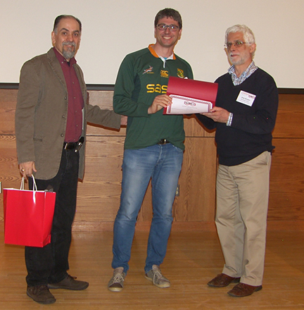
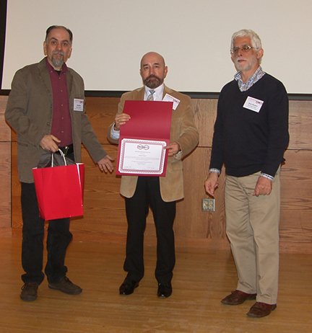
Above from the left: Mehrdad Negahban, Victor M. Castaño and Jean-Jacques Pireaux.
The Bruce Hartmann Prize for Young Scientists went to: Brett Fors (in the middle below), Department of Chemistry and Chemical Biology, Cornell University, Ithaca, New York: Deterministic Control of Polymer Molecular Weight Distribution
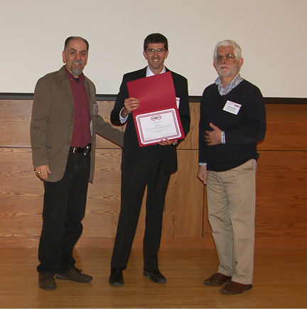

The Jürgen Springer Prize for Young Scientists went to: Carolina Gonçalves (in the middle below), College of Engineering, University of Porto: Xanthan Gum and Chitosan as Natural Adhesives for Cork

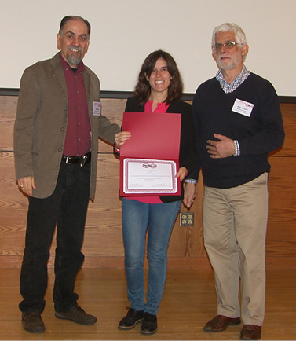

Three Carl Klason Student Awards went to:
Yoga Salim, Department of Chemistry, Faculty of Applied Sciences, Universiti Malaya, Kuala Lumpur: Thermal Degradation in the Melt Reaction betweenPoly(3-hydroxybutyrate-co-3-hydroxyhexanoate) and Epoxidized Natural Rubber;
Kaspars Maleckis, UNL Mechanical and Materials Engineering Department: Ultrahigh-Performance Nanofibres from DNA and Proteins;
Hao Liu, Department of Polymer Science, University of Akron, Akron, Ohio: Two-Dimensional Nano-Crystals of Molecular Janus Particles

The IUPAC Poster Prizes for students were given to:
Evan Schwahn, UNL Mechanical and Materials Engineering Department, USA: Controlled Curing of Acrylate: System Modelling and Application in Stereolithography;
Franz Lanyi, Institute of Polymeric Materials, University Erlangen-Nuremberg: Novel Chart For Representation of Material Performance and Reliability;
Taylor Stockdale, UNL Mechanical and Materials Engineering Department, USA: Manufactoring of Polyimide Fibre-Reinforced Nanocomposites
Diplomas of Distinction for Student Presentations went to:
Taria Jamil, Polymer Engineering Department, University of Akron, Akron, Ohio: Mechanism of Molecular Interaction of Superplasticizer Oligomers with Hydrated Cement Phases;
Xue Li, Chemistry Department, University of Alberta, Edmonton: Polymer-Based Materials for Building Artificial Muscles and Three Dimensional Structures by Self-Rolling;
Yaping Ding, Institute of Polymeric Materials, University of Erlangen-Nuremberg: Electrospun PHB/PCL/Fumed Silica Fibrous Structure for Bone Tissue Engineering;
Simon Schönherr, Graphene-Based Nanotechnology, University of Siegen, Germany: Investigation of Electronic Properties of a Graphene Field Effect Transistor
Limited funds were granted by IUPAC for the support of graduate students and young scientists from third world countries. However, due to high expectations by the applicants and visa problems, it was only possible to so support one young scientist:
Bishnu Prasad Neupane, School of Health and Allied Sciences, Pokhara University: Conversion of Waste Paper into Bioplastics—Poly(lactic acid)
Mehrdad Negahban, his colleagues and collaborators at the University of Nebraska, deserve our thanks for their effective organization of the Course and the Forum. Their world was was appreciated by the participants in Lincoln.
POLYCHAR 24 is scheduled for Poznan, Poland, for May 9 – 13, 2016,
POLYCHAR 25 is planned in Kuala Lumpur, Malaysia, for October 2 – 6, 2017.

