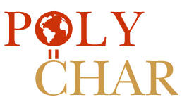 25th World Forum on Advanced Materials (POLYCHAR 2017)

POLYCHAR 2017 = The 25th Annual Forum (derived from POLYmer CHARacterization), under the auspices of the Scientific Committee of the World Forum on Advanced Materials, in cooperation with the International Union of Pure & Applied Chemistry (IUPAC), was hosted by the Institut Kimia Malaysia at the Putra World Trade Centre, Kuala Lumpur, Malaysia on October 9th-13th 2017. A total of 2 plenary, 9 invited, 55 oral and 48 poster presentations were delivered by participants from 31 countries. With the significance of the 25th anniversary of the series, it was an occasion for more than usual celebration, coinciding also with the 50th anniversary of both the Institute Kimia Malaysia and the IUPAC Polymer Division. The conference dinner was attended by the Malaysian Minister of Science, Technology and Innovation, Datuk Wilfred Madius Tangau. At the closing ceremony Dr. Kevin Menard (Veritas Testing and Consulting), one of the founders of POLYCHAR, talked about how far the series has come from its beginning as an opportunity for graduate students at the University of North Texas to practice giving presentations about their projects.

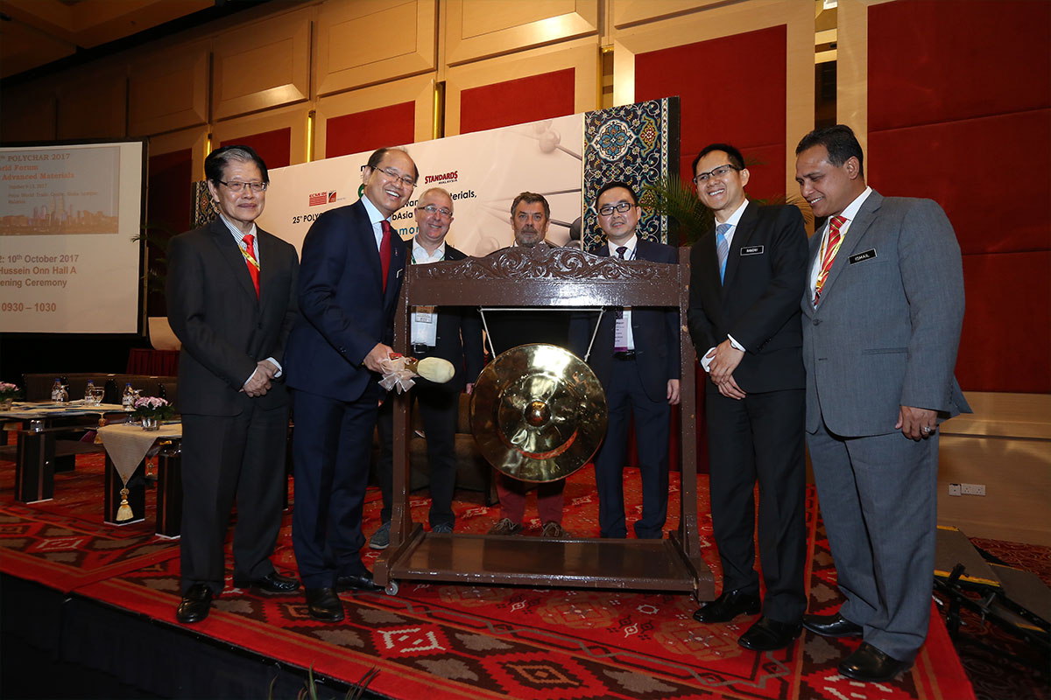
Figure 1. Joint opening ceremony of 25th World Forum on Advanced Materials (POLYCHAR 2017); the 8th Biennial Regional Symposium on Total Laboratory Management – Quality, Safety, Environment and Laboratory Informatics (QSEL2017); and the LabAsia 2017
From left: Dato’ Dr. Ong Eng Long (President, IKM and the Organizing Chairman of POLYCHAR2017), Datuk Seri Panglima Wilfred Madius Tangau (Minister Of Science, Technology and Innovation Malaysia), Prof. Greg Russell (President of IUPAC Polymer Division), Prof. Jean-Marc Saiter (Vice President of the POLYCHAR Scientific Committee), Mr. C. P. Saw (Managing Director of ECMI ITE), Assoc. Prof. Ramzah Dambal (Deputy Secretary-General of Ministry of Science, Technology and Innovation Malaysia) and Datuk Haji Ismail Bin Talib (Director General, Department of Chemistry Malaysia)

The philosophy of POLYCHAR is to visit a different part of the world each year to give students and young scientists an opportunity to present their scientific work to a large international audience, to meet prominent scientists, and to attend tutorials held by international well-known scientists. Previous POLYCHAR meetings had been held in Denton, Texas, (where POLYCHAR had been founded in the year 1992), Guimaraes, Portugal (2004), Singapore (2005), Nara, Japan (2006), Buzios, Brazil (2007), Lucknow, India (2008), Rouen, France (2009), Siegen, Germany (2010), Kathmandu, Nepal (2011), Dubrovnik, Croatia (2012), Gwangju, South Korea (2013), Stellenbosch, South Africa (2014), Lincoln, Nebraska, USA (2015) and Poznan, Poland (2016).

Conference presentations ranged broadly over a variety of topics. They were organised under the themes of:
- Advanced biological, biomedical and environment-friendly polymers
- Electroactive polymers
- Latex chemistry and technology
- Materials for clean and sustainable energy
- Multi-techniques of materials characterization
- Nanomaterials and smart materials
- Natural and synthetic elastomers
- Polymers and nutrition
- Polymeric gels and soft matter
- Processing, rheology and mechanical properties

Two plenary lectures were presented by Zairossani Mohd Nor [Deputy Director General, (Research and Innovation) of the Malaysian Rubber Board] on Positioning R&D towards Innovative and Sustainable Rubber Industry and Volker Abetz (University of Hamburg, Germany) on Polymer Membrane Characterization by Scattering, Microscopy, and Thermal Methods.

The Short Course in Polymer Characterization, a POLYCHAR tradition, was supported by IUPAC and held on the first day of the meeting. Seven prestigious researchers delivered graduate-level tutorial presentations on the following topics:
- Characterization of polymer electrolytes by dielectric response using Electrochemical Impedance Spectroscopy (Chan Chin Han, MARA University of Technology, Malaysia)
- Thermal analysis used to analyze the glass transition phenomenon (Jean-Marc Saiter, University of Rouen, France)
- Viscoelastic properties of polymers (Michael Hess, University of North Texas, USA)
- A simple approach to the mathematical treatment of diffraction and scattering of X-ray and visible light (Masura Matsuo, Nara Women’s University, Japan)
- Determination of thermodynamic properties by scattering techniques (Volker Abetz, University of Hamburg, Germany)
- Micromechanics of polymers by electron microscopy (Sven Henning, Fraunhofer Institute for Microstructure of Materials and Systems, Halle/Saale, Germany)
- Characterisation of crosslinks in vulcanised rubbers: From simple to advanced techniques (presented by Kok Lang Mok of the Malaysian Rubber Board for Aik Hwee Eng of the Institute Kimia Malaysia).

The Short Course speakers were available for all participants for further discussions throughout the Forum and the short course notes can be accessed on a IUPAC website: https://iupac.org/projects/project-details/?project_nr=2016-033-1-400.

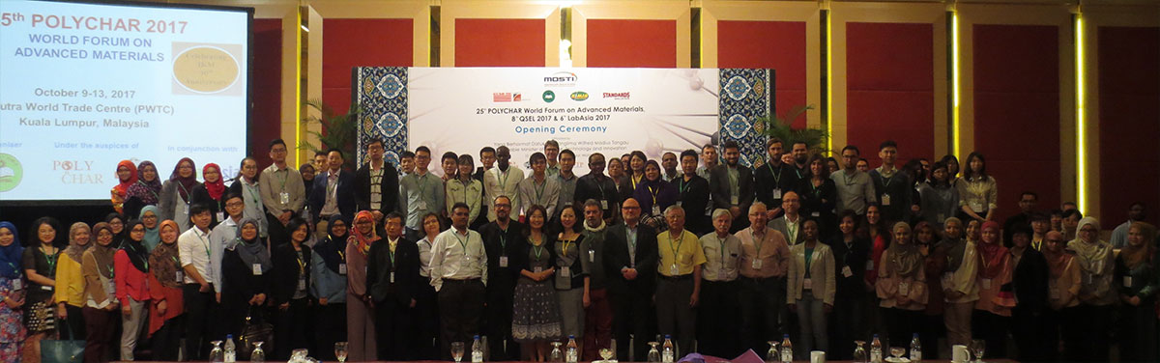
Figure 2. Short Course participants and speakers

In the POLYCHAR tradition, a number of prizes were awarded at the conclusion of the event. The prestigious Paul J. Flory Research Prize 2017 went to Volker Abetz of Institute of Polymer Research of the Helmholtz-Zentrum Geesthacht and University of Hamburg, Germany, for his exemplary research into block copolymer behavior.

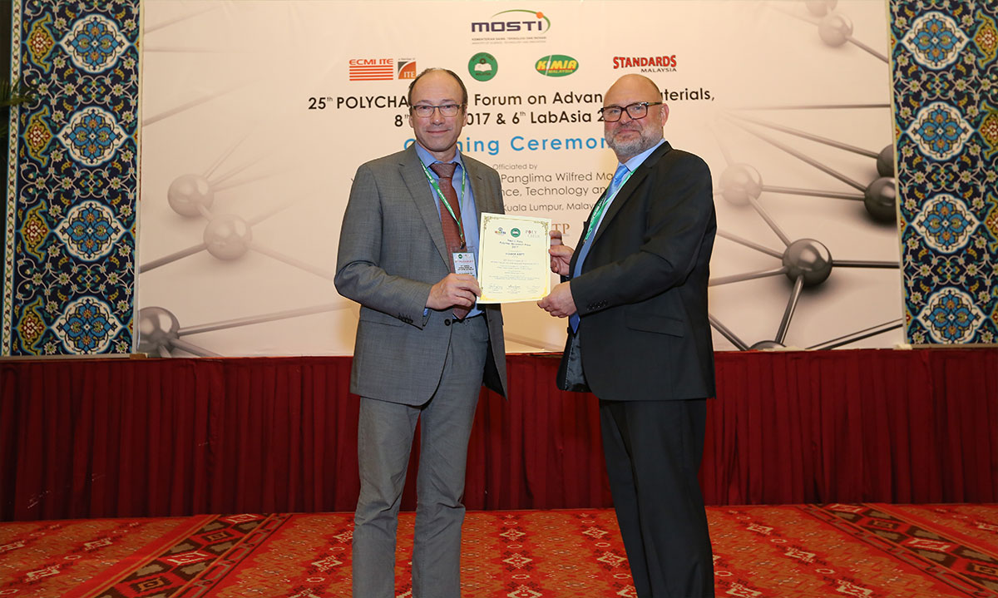
Figure 3. Paul J. Flory Research Prize 2017
Volker Abetz (left) and Sven Henning (right - Chairman of POLYCHAR Prize Committee)

The International POLYCHAR Materials Research Prize 2017 was awarded to Kevin Menard, one of the founders of the POLYCHAR series for his life’s work in the science of polymer materials.

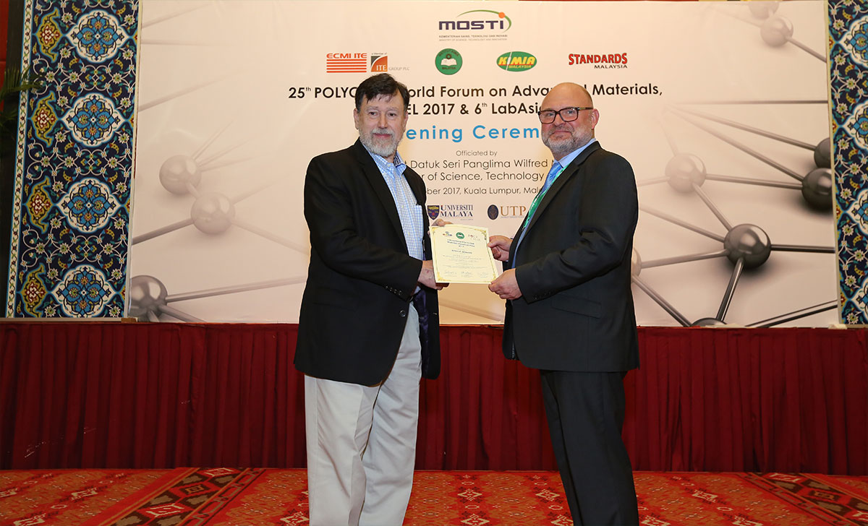
Figure 4. International POLYCHAR Materials Research Prize 2017
Kevin Menard (left) and Sven Henning (right)

The Bruce Hartmann Prize for Young Scientists was awarded to Valentina Marturano of the University of Naples, Italy, for her presentation entitled Visible light responsive polymer nanocapsules.

The Jürgen Springer Prize for Young Scientists was awarded to Dou Xiaoqiu of the University of Siegen, Germany, for her presentation entitled Novel 3D micropatterned poly(vinyl alcohol) hydrogel platform for the controlled formation of cell spheroids.

Three Carl Klason Student Awards were awarded to:
- Florian Kung, Friedrich-Alexander-University Erlangen-Nuremberg, Germany, for his work on the suture-ability of grafts for ocular surface reconstruction;
- Jian Liu, University of Science and Technology of China, for her presentation on Trifunctional CdSe Quantum Dots-Polymer Composite Film with Electrochromic, Electrofluorescent and Light-Induced Coloration Effects;
- Jyoti Giri, Tribhuvan University, Kathmandu, Nepal, for her presentation entitled Poly(butylene adipate-co-terephthalate) composites with wheat stalk microcellulose: morphological, mechanical, thermal and biodegradation behavior.

Three IUPAC Poster Prizes were awarded to:
- Benoit Basse, Onyx Développement, for his poster on Peanut suspensions crosslinked by means of microbial transglutaminase;
- Khong Choy Hung, Tunku Abdul Rahman University, Malaysia, for her poster on Effect of carbon nanotubes in polyaniline nanocomposites on heavy metal removal;
- Muchao Qu, Friedrich-Alexander-University Erlangen-Nuremberg, Germany, for her poster on Conductivity of melt spun poly(methyl methacrylate) composites with aligned carbon fibers.

Four IUPAC Fellowships were offered by IUPAC for the support of graduate students and young scientists from developing countries, which were awarded to Chayaporn Pareseecharoen (Thailand), Jyoti Giri (Nepal), Lau Kam Sheng (Malaysia) and Manus Sriring (Thailand).

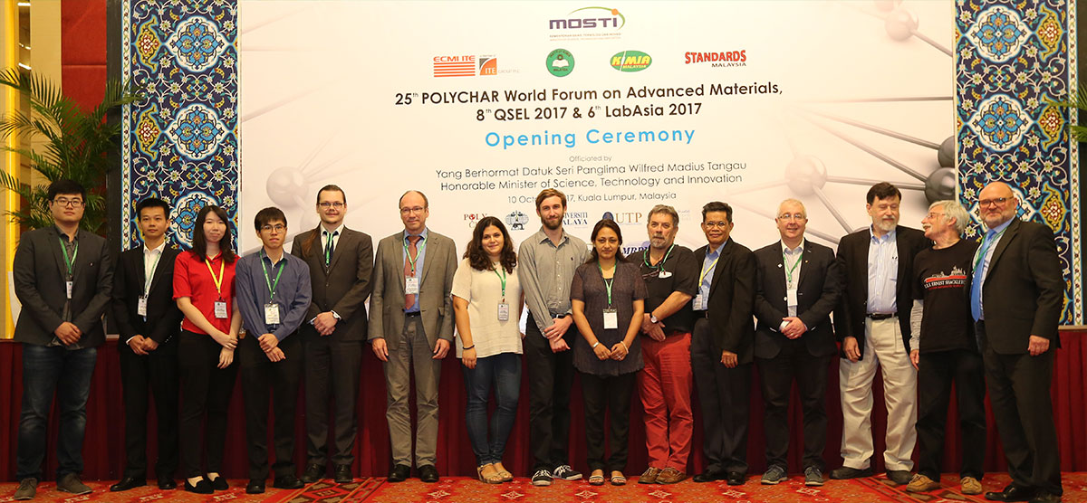
Figure 5. Recipients of POLYCHAR Prizes, IUPAC Fellowship, members of POLYCHAR Scientific Committee, IUPAC Polymer Division and POLYCHAR 2017 organizing committee

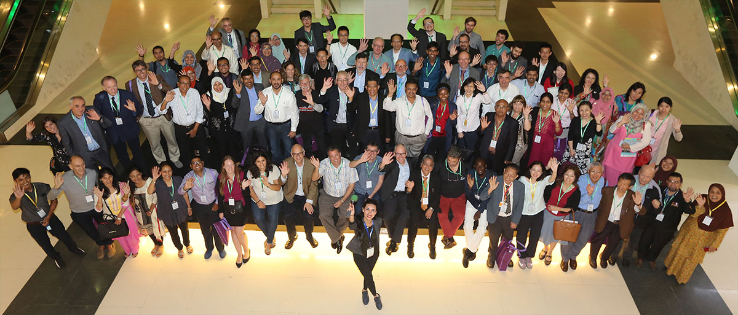
Figure 6. Participants at closing of POLYCHAR 2017

The 6th Malaysia Scientific and Laboratory Equipment Exhibition and conference (LabAsia 2017) was held in conjunction with POLYCHAR 2017 and QSEL 2017. This biennial international trade exhibition for laboratory equipment and services serving the ASEAN scientific community was jointly organised by IKM and ECMI ITE Asia Sdn Bhd. More than 6,000 visitors attended the three-day exhibition. LabAsia 2017 featured 154 exhibitors and principals from ten countries, including China, Germany, France, Britain and the United States, showcasing new products and services.

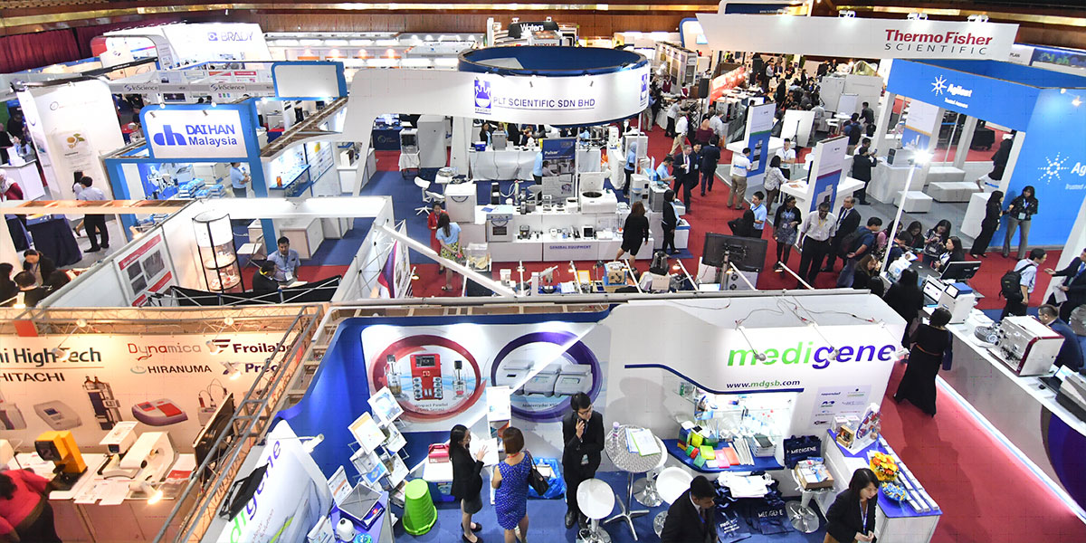
Figure 7. LabAsia2017

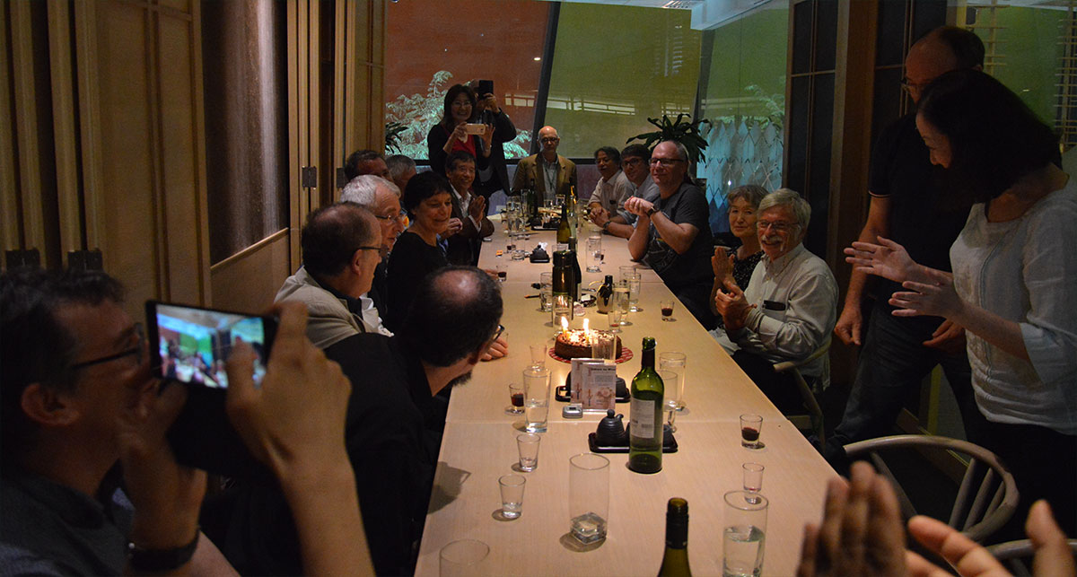
Figure 8. 25th Anniversary Dinner of POLYCHAR

All participants are very grateful to the Organizing Committee for the successful Forum. Particular thanks are due to Chin Han “Melissa” Chan for tremendous work she has done! Melissa had more work than the organizers in the previous years - given the need to achieve coordinations with the Government of Malaysia, IUPAC, LabAsia2017 and more.

POLYCHAR 2018 is planned for Tbilisi, Georgia. An announcement will be made with the deadline for presentation submission.

